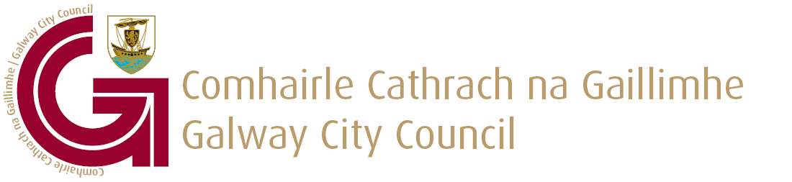

BRANDING AND SIGNAGE POLICY

Introduction

The objective of this policy is “provide a framework for a coherent visual branding of the City, its attractions, festivals and international connections to advise residents and visitors”.

It is intended that this policy will be implemented by the following departments of the Council, all of whom have responsibilities for dealing with advertising signs on public places. The statutory basis for this policy is outlined in the following legislation:-

- Roads Department (under the Roads Act 1993 as amended).
- Planning Department (under the Planning & Development Acts).
- Environment Department (under the Litter Pollution Act 1997-2003).

This policy will be implemented in consultation with other relevant departments of the Council as appropriate.

There are three types of signage which could be made available for branding/event promotion currently in Galway City and it has been established that there is a need for a clear, consistent approach required for the usage of these signs.

Advertising structures, where required, shall be sized and placed in a manner, which is unobtrusive. Advertising structures and signage shall be minimised, of a high standard, co-ordinated in design and appropriately scaled and located (City Development Plan 2011-2017).

This policy will seek to control and optimise the use of:-

► Obsolete National Development Plan (NDP) signage
► Road Safety Authority (RSA) signage
► Information Plinths

NDP Signs (not for use by third parties)

It is proposed to brand the City and City Council in a positive manner, highlighting significant civic features such as twinning, with other link/twin cities, e.g. Bradford, Lorient, Chicago, Aalborg and Seattle as well as permanent designations for e.g. “UNESCO City of Film”.

1/3

RSA Signs (16 No.)

RSA Signs will continue to be made available on an annual basis to cultural and sporting events of scale and quality, which attract significant numbers of visitors to the City.

Signage will be in place for a period one month including the event, and will be removed no later than seven (7) days after the end of the event.

For the remainder of the year, the RSA signs will be used to promote Road Safety and a Litter Free City.

> Applications from the organisers of the festivals must be received one month prior to the
signs being erected.
> Layout will be clear and simple with one strong central image promoting the Festival
only and will not contain reference to the sponsors of the event either explicitly or
implicitly.
> Logos permitted are Galway City Council and Festival logo.
> A combination of words and numbers will be kept to a maximum of ten.
> All graphic designs will be submitted with the application and will be subject to revision
as required by the City Council.
> In lieu of payment for use of the signs, boards will include Galway City Council
approved logo. Galway City Council's logo will be made available in digital graphic
format.
> All costs associated with the erection and removal of the signage is borne by the event
promoter.
> All applications must be accompanied by details of the promoter including appropriate
details such as insurance, method statements etc.
> A cash deposit will be paid in advance of the erection of any sign. The deposit will be
refunded after the signage is removed within seven (7) days at the end of the event.
> All sixteen (16) RSA signs must be used unless Galway City Council require them for
other purposes.

Information Plinths

Information Plinths are tall rectangular signs which Galway City Council have permitted to be erected on certain public lighting poles. They are three sided, supported on a steel frame of sound construction and designed to limit damage to the public lighting poles. A photographic example of these plinths can be seen in the appendix. They are dressed in a durable metallic/plastic compound. Under no circumstances will corriboard or similar weak materials be accepted for use on these plinths. The purpose of these plinths is to display information to pedestrians (not motorists).

Taking into account the existence of Archaeological Conservation areas in the City centre area, permission for the erection of Information Plinths at a maximum of ten (10) pre-approved locations may be allowed in the City centre and a maximum of three (3) in Salthill. Alternative locations will be considered upon application but will depend on factors including, but not limited to path width and visibility to pedestrian areas.

Plinths will be in place for a maximum of two (2) weeks at a cost of €31.50 per plinth in
2/3

accordance with Section 254 of the Planning and Development Act 2000, as amended.

The promotion of festivals, culture, arts, sporting events, events organised by charities and services taking place in the City of general interest to the public is the primary use of advertising on plinths. The plinths can be attractive and colourful. See Appendix for examples.

Applicants should allow a minimum of four (4) weeks before the required booking date for approval, production and installation of plinths.

The City Council is the sole owner of the advertisement space. The City Council may make space available for promoting activities and attractions, subject to the following terms and conditions.

> Galway City Council approved logo will be included. Galway City Council's logo will be
made available in digital graphic format.
> The direct and indirect promotion of private and commercial corporations, businesses and
organisations and related products and services shall not be permitted on the plinth.
> Political campaigns either within Ireland or internationally shall not be permitted.
> Applications from the organisers of the above festivals must be received one month prior
to the signs being erected.
> Logos permitted are the Galway City Council and the festival or event logos (excluding
commercial or title sponsors).
> All graphic designs will be submitted with the application and will be subject to revision
as required by the City Council.
> All costs associated with the erection and removal of the signage is borne by the event
promoter.
> All applications must be accompanied by details of the promoter including appropriate
details such as insurance, method statements etc.

Copyright of Information Plinth artwork/production is the responsibility of the client. Galway City Council takes no responsibility for any copyright issues.

Artwork Criteria

All artwork for plinths must be approved in advance, by the Planning and Transportation Directorate, Galway City Council, and comply with the required dimensions.

Booking applications will be dealt with on a first-come first-served basis.

The granting of a licence at any location will not be deemed to constitute a precedent.

Unauthorised signage on the public road may be removed by Galway City Council under the Roads Act 1993 (Section 72). Unauthorised signage on private property may be pursued under Planning Enforcement.

FEBRUARY 2016

3/3

